LED CHASER

CIRCUIT DIAGRAM-

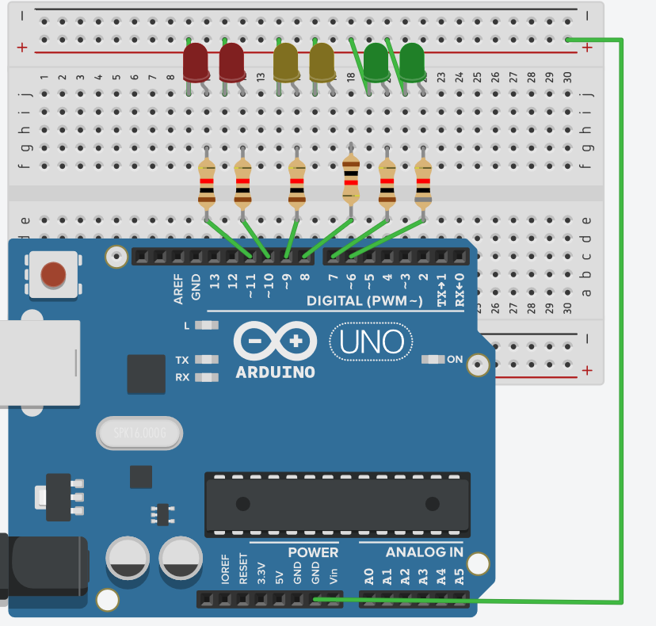

HARDWARE REQUIRED-

1.LED

2.BREADBOARD

3.ARDUINO BOARD

4.RESISTORS

5.WIRES

CONCEPT USED-

Led flasher is a simple blinking of led in a particular pattern by connecting them to a resistor .The components of circuit are connected in parallel.

LEARNING AND OBSERVATIONS-

In this project we learnt about the blinking of leds in a particular pattern,2 led at a time and learnt about the use of breadboard.

Problems & Troubleshooting

In this project I faced many problems while connecting the circuit.

I also faced problem in doing coding for the Arduino board.

Precautions:

1. Use circuit diagram for connecting circuit on breadboard.

2. select correct pins while coding.

3. Wires Should Be Plugged into board properly.

LEARNING OUTCOMES-

In this project I learnt about the working of led flasher in a particular pattern,2 led at a time simultaneously.